Contents

1. Self-Evaluation Document (10) 2

Feedback received 4

Assignment 1 5

Assignment 2 6

Assignment 3 7

How I improved on the feedback 7

# 1. Self-Evaluation Document (10)

|  |  |  |  |  |
| --- | --- | --- | --- | --- |
| **Criteria** | **1**  **You’ve learned something – but you’re not proving it!** | **2**  **You’re on the right track but**  **you can do better!** | **3**  **Bravo! You’ve done exceptionally well!** | **Score** |
| Reflection | * Reflection   shows no thoughtfulness.   * Reflection has no details. * Reflection is incomplete. | * Reflection   shows little thoughtfulness.   * Reflection has few details or examples. * Most parts of the reflection are incomplete. | * Reflection   shows thorough thoughtfulness.   * Reflection has   several supporting details and examples.   * All parts of the reflection are complete and done well. | 3 |
| Demonstration  of learning | * Reflection does   not move beyond description of the event/ experience. | * The reflection   demonstrates student’s attempt to analyse the event/ experience but fails to demonstrate depth of analysis. | * Clearly   explains what was learned.   * Reflection is beyond simple description of event/ experience to an analysis of how it contributed to learning and understanding. | 3 |

|  |  |  |  |  |
| --- | --- | --- | --- | --- |
| **Criteria** | **1**  **You’ve learned something – but you’re not proving it!** | **2**  **You’re on the right track but**  **you can do better!** | **3**  **Bravo! You’ve done exceptionally well!** | **Score** |
| Organisation  of report Clarity of report | * Ideas are   disorganised.   * Language is unclear and confusing throughout. | * Ideas are   organised but paragraphs are not well constructed.   * Frequent lapses in clarity. | * Ideas are very   well organised with well- constructed paragraphs.   * The language is clear and expressive. * The reader can create a mental picture of the situation being described. * Explanation of concepts makes sense to an uninformed reader. | 3 |
| Inclusion of lecturer’s feedback on Assignments 1 -3 (1 mark) | | | | 1 |
| **TOTAL /10** | | | | |

# Feedback received

# C:\Users\15009851\Desktop\assigment 1.jpgAssignment 1

## Assignment 2

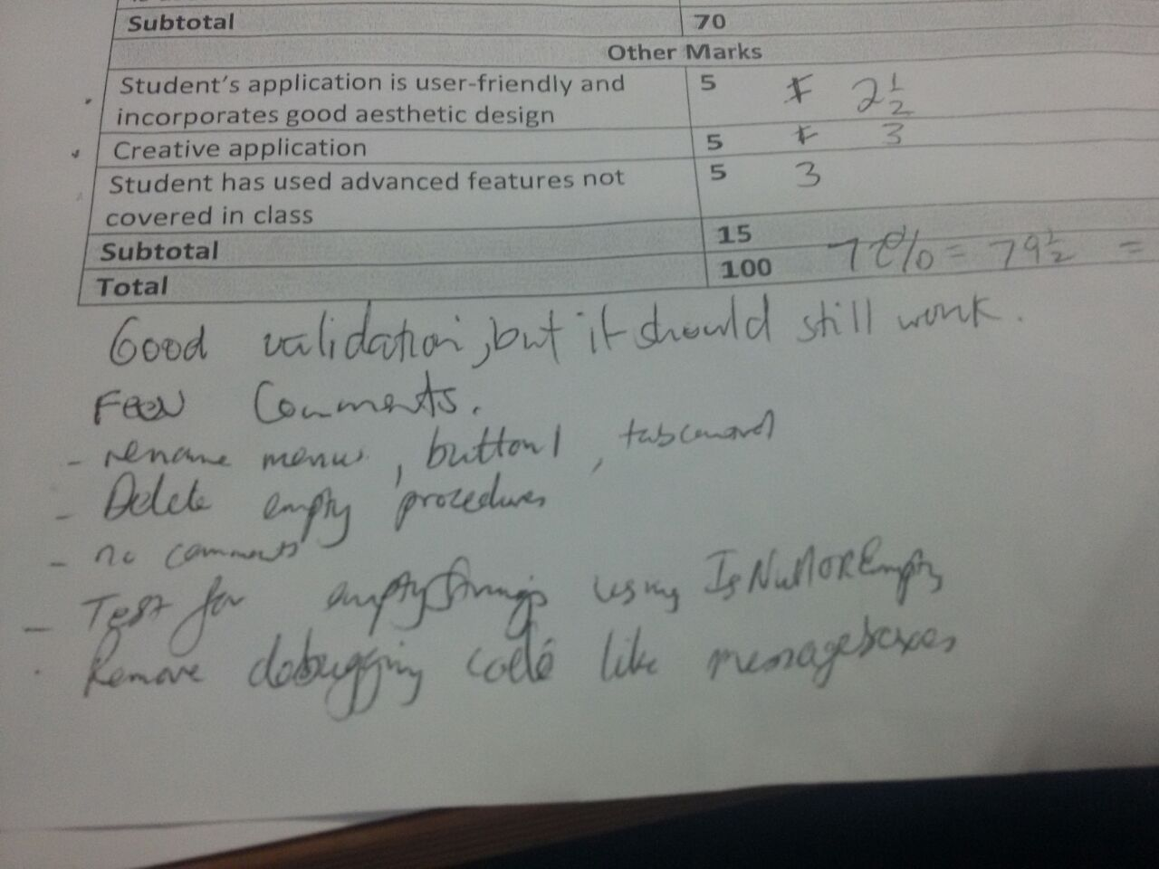

## Assignment 3

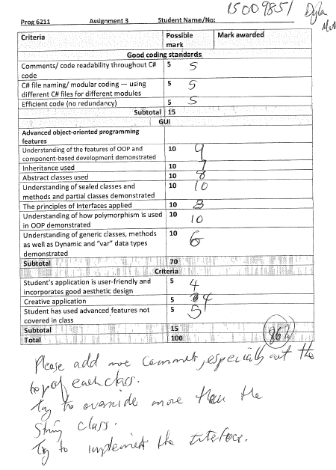

# How I improved on the feedback

I deleted empty methods.

I don’t have any unused imports.

Got rid of spelling errors.

I validate all user import data.

Don’t have any default names for buttons and stuff.

Added more comments at top of classes.

I changed the add/sell screen because there were too many forms, so I tabbed all the categories.